

FortnaPlus Control
Remote Authorization
Document Revision: 1.1
Date: 03-Oct-2022

Revision | Date | Author | Revision Summary
0.6 | 20-Dec-2012 | T R Kremser | New document
1.0 | 27-Apr-2022 | T R Kremser | Update and general refresh
1.1 | 03-Oct-2022 | T R Kremser | Update rc.local information for stunnel

Table of Contents
Glossary of Terms 4
1. Introduction 5
2. Project Overview 5
3. User Interface 6
3.1. Machine Table 6
3.2. MsgMap Table 9
3.3. RemoteAuthCfg Table 11
4. Debugging 13
4.1. Debugging ActiveMQ 13
5. Secure Configuration 16
5.1. Building the Stunnel Package 16
5.2. Configure Stunnel 18
5.3. Apache ActiveMQ Configuration 20
6. Automation Controller Software Changes 22
6.1. ActiveMQ Connection 22
7. Binary Packaging 24
7.1. Installer Disk 24

Confidential/Proprietary Statement
This document contains trade secrets and information that is considered confidential and proprietary to Fortna, Inc. It may not be duplicated, used, or disclosed outside the original recipient organization, and it may not be duplicated, in whole or in part, for any purpose other than to evaluate this document. Fortna Material Handling reserves the right to modify this document as necessary to reflect any terms and conditions negotiated and included as part of a subsequent contract or purchase order.

Glossary of Terms
AC – Automation Controller
FPC – FortnaPlus Control

Introduction
This document describes the operation and configuration of the remote authorization module of FPC. Th intended audience is the FortnaPlus software development team and the Controls Engineering group.
Controls Engineering will be most interested in sections Error! Reference source not found., Error! Reference source not found., Error! Reference source not found., and 5.2.
Associates configuring ActiveMQ will be interested in sections Error! Reference source not found. and 5.3.

Project Overview
The Remote Authorization module provides a way to manage the username, password, and security roles of each user in FPC through a remote system. The feature builds upon the conventional static user authorization model, where passwords are managed locally. The AC queries the remote system to determine if the username and password are valid, and, if so, to retrieve the user’s authorized roles. Clients that use an LDAP (or similar) access management system can use this module to integrate FPC into their corporate scheme.
When a user attempts to log in, first a local (static) authentication is attempted. If that fails, a Remote Authentication request is made. A successful Remote Authentication request will return a list of authorized roles that the user has privilege to use.
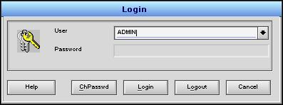
Automation Controller
ActiveMQ Server

LDAP Server
Stomp Message
topic
topic
Stomp Message

User Interface
This section describes how to configure an AC for Remote Authentication.
  - Machine Table
Use the Machine table (Configuration Menu | Communication Utilities | Machine) to define the connections to other machines. Any fields not mentioned here should be left at their default values. Two entries are needed to define the connections for outbound and inbound messages.
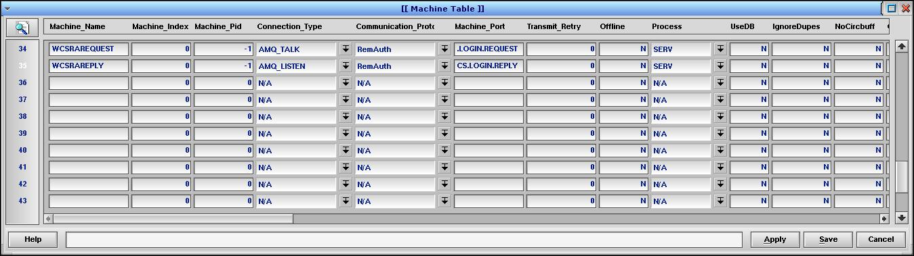

    - Machine_Name
Type: STRING
The name of the machine to connect to. The name must resolve to an IP address, usually via an entry in /etc/hosts, but DNS lookup could also be used. The name given here must be unique, but multiple machine names can resolve to the same IP address, if desired.
NOTE: If the /etc/hosts entry or DNS lookup does not produce a valid result, you will see message send attempts in the SERV log at 11 second intervals.
For unsecured connections, connect directly to the ActiveMQ server with an /etc/hosts similar to this:
192.168.10.50 WCSRAREQUEST WCSRAREPLY
For secured connections, use stunnel (see section 5). Stunnel creates local ports so the /etc/hosts file would refer to the local machine with an entry like this:
127.0.0.1 WCSRAREQUEST WCSRAREPLY

    - Machine_Pid
Type: INTEGER
The Machine_Pid is a large integer value assigned by the system when a connection is established. If the connection has not been established the Machine_Pid will display as -1. FPC will attempt to re-establish inactive connections every few seconds. You can cause a connection to reset on command by setting this field to -1 manually. In older versions of FPC, server-style connections may not detect that the other machine has dropped the connection for several hours. Manually resetting the connection can be helpful in this situation.

    - Connection_Type
Type: POP-UP SELECTION UNIQUE to table Connect
This field defines the communication method. For Remote Authorization, use AMQ_TALK to request authorization and AMQ_LISTEN to receive the authorization response. The AMQ connection types use stomp-formatted messages over TCP/IP to an ActiveMQ server.
The ActiveMQ server is a message broker that provides messaging services to clients. Two types of connections are available: Queues and Topics.
When multiple clients subscribe to a single Topic, all the subscribers will receive a copy of each message that is posted to that Topic.
When multiple clients subscribe to a single Queue, only one of the subscribers will receive a given message, which is then said to have been consumed.
The Remote Authentication module uses Topics.
Stomp is a text-based protocol that is easy to view with network sniffing tools.
The TCP/IP layer will connect to the ActiveMQ server on hard-coded port 61613 (stomp).

    - Communication_Protocol
Type: POP-UP SELECTION UNIQUE to table Protocol
The Communication_Protocol determines the format of the content of each message. Use the RemAuth type for both connections.
The RemAuth protocol will format a remote authorization message with:
<STX><Machine Name>|<Time Stamp>|<User Name>|<Password>|<Context>|<Reply topic><ETX>
For example:
CP2|20120131114725|hrollins|blackflag4ever|FPC_CONTEXT|WCS.LOGIN.REPLY
The reply will be formatted as:
<STX><Machine Name>|<Time Stamp>|<User Name>|<Password>|<Context>|<Reply topic>|<Login success?>|<Security Roles>|<Language><ETX>
For example:
CP2|20120131114725|hrollins|blackflag4ever|FPC_CONTEXT|WCS.LOGIN.REPLY|true|Login successful|384|en-US
STX is ACSII character 2 and ETX is ASCII character 3
The Security Roles are a bit-encoded integer. The roles and associated integer value can be seen by right-clicking on any security field in FPC, such as the Level field in table Password.
    - Machine_Port
Type: STRING
The Machine_Port field defines the ActiveMQ topic, not the TCP/IP port. For Remote Authorization requests the topic will be /topic/WCS.LOGIN.REQUEST. For remote authorization replies, use the default /topic/WCS.LOGIN.REPLY. The Remote Authentication engine may be configured to deliver the reply through other topics, if needed, so use the agreed-upon topic here. The ActiveMQ server will automatically create requested topics.
For secured connections, the Username and Password fields in table Machine must match the configuration defined for the topic on the ActiveMQ server.

    - Transmit_Retry
Type: INTEGER
Leave as default value.

    - Offline
Type: BOOLEAN INTEGER (Y/N)
This field is set by the program. If set to Y, check your connection configuration.

    - Process
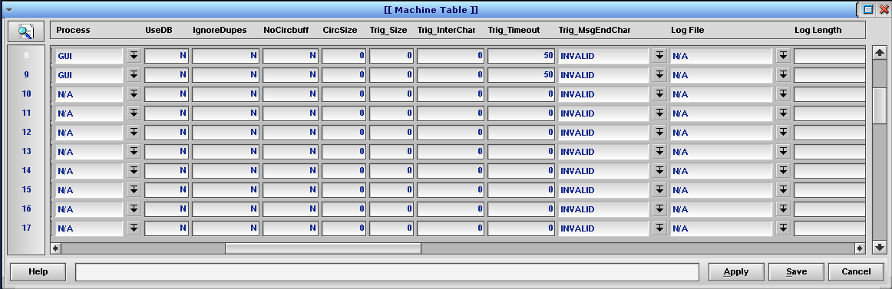
Type: POP-UP SELECTION UNIQUE to table Process
Select the FPC process that will handle the connections. To avoid interfering with time-sensitive messages associated with operation of the conveyor, choose the GUI process.

    - NeedACK
Type: INTEGER
Set this value to 0. The Request and Reply occur on separate channels, so no acknowledgement is expected.

    - LogLevel
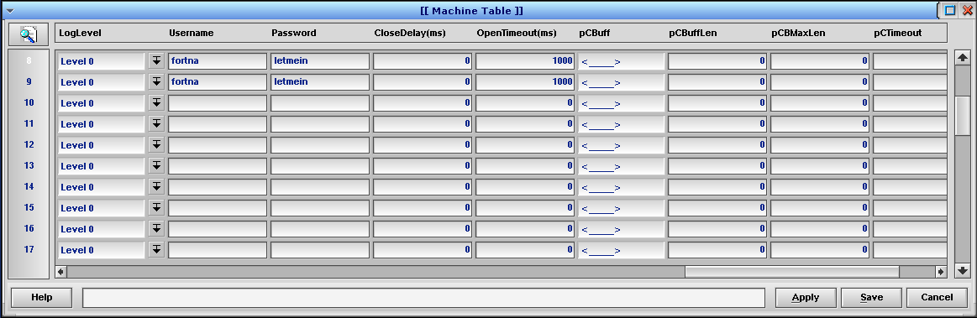
Type: POP-UP SELECTION UNIQUE to table LogLevel
Controls the level of detail written to the log files. Set to Level 0 for normal operation to avoid writing sensitive information to the log files. Set to Level 1 to assist with debugging.

    - Username and Password
Type: STRING
Define the username and password for the connection. This is for the connection to ActiveMQ, not an individual user’s information.
Note that the information is sent clear-text unless stunnel is used to encrypt it. See Section 5 for details.

    - OpenTimeout(ms)
Type: INTEGER
Set to 1000 (1 second) to avoid connection problems. This field controls the amount of time FPC will pend waiting for the ActiveMQ connection to open. Remote Authorization connections have been found to take more than 400 milliseconds to complete. While the open is in progress, the process will not be able to do anything else but wait. We can tolerate this delay in the GUI process. Do not use the SERV process, as delaying it for more than 10 ms will cause sorter and transfer issues.

  - MsgMap Table
The MsgMap table (Configuration Menu | Communication Utilities | Message Map) defines the link between Machine connections and the tables that store messages. Any fields not mentioned here should be left at their default values.
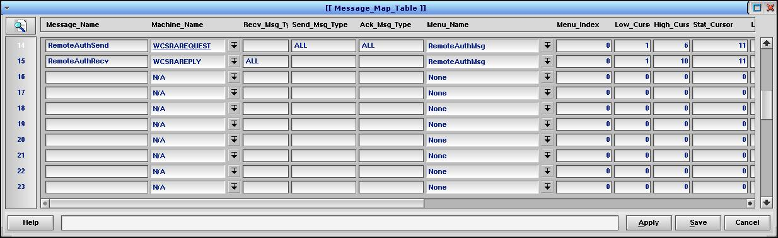

    - Message_Name
Type: STRING
A unique identifier for the record. For remote authorization a send and a receive entry are needed.

    - Machine_Name
Type: POP-UP SELECTION UNIQUE to table Machine
Choose the Machine table record associated with this connection.

    - Recv_Msg_Type, Send_Msg_Type, Ack_Msg_Type
Type: STRING
These fields act as filters for the messages. How the messages are filtered depends on the Communication_Protocol in the Machine table. For the RemAuth protocol the valid values are:
Empty – Do not accept messages
ALL – Accept any message
Machine name – Accept messages for the listed machine.
For the remote authorization request message these fields should be set to:
- Recv_Msg_Type – empty
- Send_Msg_Type – Machine name or ALL.
- Ack_Msg_Type – empty
For the remote authorization reply message these fields should be set to:
- Recv_Msg_Type – Machine name or ALL.
- Send_Msg_Type – empty
- Ack_Msg_Type – empty.

    - Menu_Name
Type: POP-UP SELECTION UNIQUE to table MenuMenu
Choose the table to send data to or receive the data from. The table to use depends on the message type, the Communication_Protocol in the Machine table, and the process in the Batches table using the data. For the RemAuth protocol, use the RemoteAuthMsg table for both the request and reply messages.

    - Low_Cursor and High_Cursor
Type: INTEGER
When messages are received, the contents of each message field are copied to a record in the table specified in the Menu_Name field. When messages are transmitted, the message fields are constructed from a record in the table specified in the Menu_Name field. For Remote Authorization, we will be using the RemoteAuthMsg table.
The Low_Cursor and High_Cursor values define the range of columns in table RemoteAuthMsg to act upon. The columns are numbered beginning with 1. The High_Cursor index in inclusive so if the Low_Cursor is 3 and the High_Cursor is 3 then one field of data is transferred.
The Remote Authorization request message contains 6 data fields.
Set Low_Cursor = 1, High_Cursor = 6.
The Remote Authorization reply message contains 10 data fields.
Set Low_Cursor = 1, High_Cursor = 10.

    - Stat_Cursor
Type: INTEGER
The Stat_Cursor field points to the TxStat column in the RemoteAuthMsg table, column 11.

    - Key_Cursor
Type: INTEGER
The Key_Cursor field points to the DbKey column in the RemoteAuthMsg table, column 12.

  - RemoteAuthCfg Table
RemoteAuthCfg (Configuration Menu | Administrator Utilities | Remote Authorization) is the top-level table for configuring Remote Authorization.
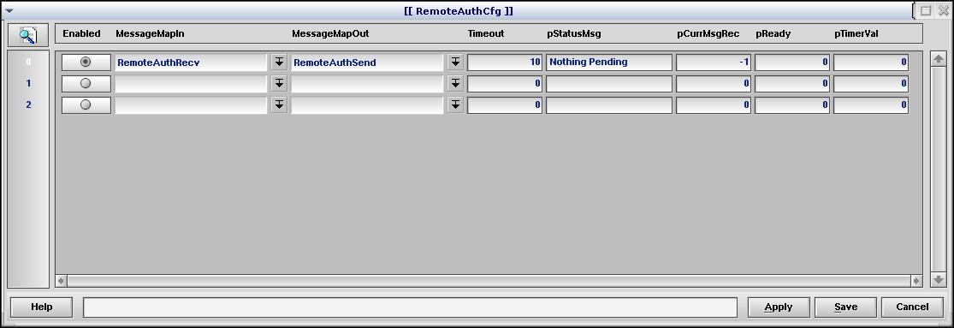

    - Enabled
Type: BOOLEAN Button (36)
Enables a source for remote authorization.

    - MessageMapIn
Type: POP-UP SELECTION UNIQUE, to table MsgMap
Points to the MsgMap table entry where Remote Authorization reply messages are parsed upon receipt.

    - MessageMapOut
Type: POP-UP SELECTION UNIQUE, to table MsgMap
Points to the MsgMap table entry where Remote Authorization request messages are parsed for transmission.

    - Timeout
Type: INTEGER
The time, in seconds, to wait for the Remote Authorization message reply to be returned before raising an error.

    - pStatusMsg
Type: STRING
Updated by the program. Contains the status of the last Remote Authorization operation.

    - pCurrMsgRec
Type: INTEGER
An internal index used by the program.

    - pReady
Type: INTEGER
An internal flag used by the program.

    - pTimerVal
Type: INTEGER
Used by the program to track the time at which the login attempt will expire. In system seconds.

Debugging
This section provides information about tools and debugging techniques for Remote Authorization. This section is targeted at the Controls Engineering and Software Development groups.

  - Debugging ActiveMQ

    - Viewing ActiveMQ Messages
If you are not receiving messages from ActiveMQ, it can be useful to view what is being sent and received from the ActiveMQ topics. A python-based console utility is available to connect to stomp ActiveMQ servers at:
http://code.google.com/p/stomppy/
or by ftp at:
ftp http://stomppy.googlecode.com/files/stomp.py-3.0.5.tar.gz
I used version stomp.py-3.0.5.tar.gz. Decompress using:
tar xvf stomp.py-3.0.5.tar.gz
By default, Fortna uses port 61613. To connect, go to the top level of stomp.py-<version> and type:
python stomp/cli.py –H <ActiveMQ IP> -P 61613
If you are connecting to a topic that is protected by a username and password over an ssl connection use the command:
python stomp/cli.py –H 127.0.0.1 -P 61613 –U <username> -W <password>
You should see:
CONNECTED:
session: ID:<server name>-<numbers>-<lots of numbers>-<number>:<number>
The topics used to process remote authorization is set in the Machine table, but the defaults are /topic/WCS.LOGIN.REQUEST and /topic/WCS.LOGIN.REPLY.
To see the messages for both topics use the command:
subscribe /topic/WCS.LOGIN.>
Or to see only the request messages subscribe to /topic/WCS.LOGIN.REQUEST with the command:
subscribe /topic/WCS.LOGIN.REQUEST
You should see the response:
Subscribing to “/topic/WCS.LOGIN.REQUEST” with auto acknowledge
You can subscribe to more than one topic at a time, so you can repeat the subscribe command for /topic/WCS.LOGIN.REPLY, if you wish.
On a successful login for username hrollins with a password of blackflag4ever you should see something like:
MESSAGE
content-length: 72
expires: 0
timestamp: 1328028294984
destination: /topic/WCS.LOGIN.REQUEST
priority: 4
message-id: ID:aapappvm-44508-1326747210330-4:777:-1:1:13

CP2|20120131114725|hrollins|blackflag4ever|FPC_CONTEXT|WCS.LOGIN.REPLY
MESSAGE
priority: 4
destination: /topic/WCS.LOGIN.REPLY
message-id: ID:aapappvm-44092-1327071133347-0:12780:1:1:1
expires: 0
timestamp: 1328028295281

CP2|20120131114725|hrollins|blackflag4ever|FPC_CONTEXT|WCS.LOGIN.REPLY|true|Login successful|300|en-US

    - Viewing ActiveMQ Server Status
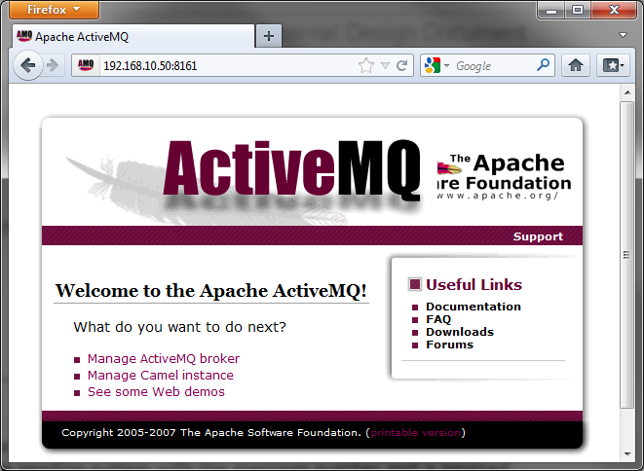
The status of an ActiveMQ server can be viewed with a web browser at:
Error! Hyperlink reference not valid.
Click the “Manage ActiveMQ broker” link.
To view the connections to the ActiveMQ server click the “Connections” link at the top.
Scroll down to find the Connector for stomp. You should see two connections for your machine’s IP address.
Clicking “Topics” at the top will show the topic on the system with a count of the number of messages posted.
If you attempt a login and you get a timeout error, look at the count for WCS.LOGIN.REQUEST. Refresh the browser and you should see the count increment by one. If not, then you do not have a connection to the ActiveMQ server or you are posting to the wrong topic. If the WCS.LOGIN.REQUEST increments but the WCS.LOGIN.REPLY doesn’t, most likely something is wrong on the server. Make sure your reply message topic is set up for /topic/WCS.LOGIN.REPLY.
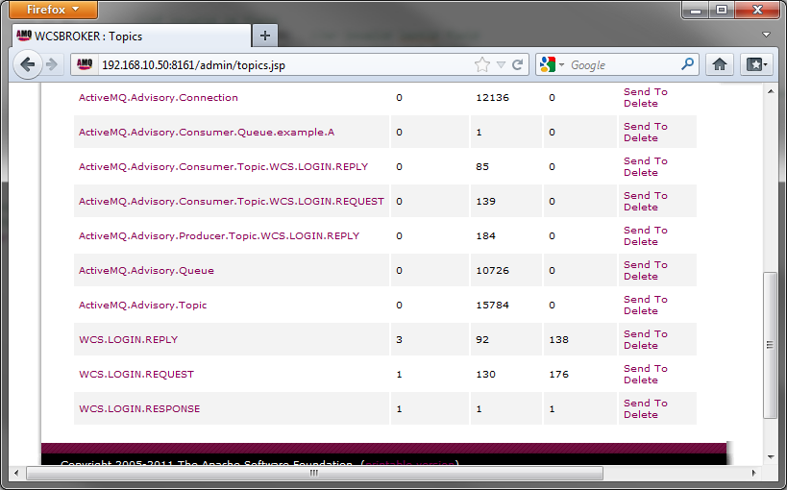
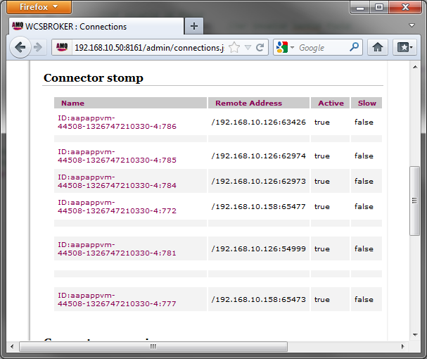

    - Loss of Received Messages
During testing, an issue was seen with messages from the ActiveMQ server being lost. During the initial connection the Remote Authorization worked but after about 30 minutes of idle connection no messages were received by the AC. Checking the message count for both the WCS.LOGIN.REQUEST and WCS.LOGIN.REPLY topics showed they were being incremented. Resetting the connection in the Machine table by setting the Machine_Pid to -1 would restore the connection for another 30 minutes.
The issue appears to be VMWare. The AC was running under VMWare and the loss of connection does not happen with a hardware machine.

    - Tracing TCP Messages
See section 6.1.1

Secure Configuration
This section describes adding encryption to Remote Authorization connections. This section is primarily targeted at the Software Development team but section 5.2 should be read by the Controls Engineer group and section 5.3 should be read by personnel configuring ActiveMQ servers.
The configuration described previously is a basic setup for Remote Authorization. Without encryption, the messages are transmitted clear-text and are vulnerable to packet sniffing techniques. This section will discuss securing the Remote Authorization communication using stunnel. Stunnel is a package for routing TCP/IP traffic through a SSL connection. The Apache ActiveMQ server natively supports a SSL-encrypted connection.
See http://www.tldp.org/HOWTO/SSL-Certificates-HOWTO/x38.html for additional information.
Automation Controller Software

LDAP Server
/topic/
WCS.LOGIN.REQUEST
WC

Stomp Message
Port 61613
Automation Controller

Stunnel
/topic/
WCS.LOGIN.REPLY
WC

Stomp Message
Port 61613
ActiveMQ Server
Stomp Message
SSL Port 61614
Stomp Message
SSL Port 61614

  - Building the Stunnel Package

    - Source
The source code for stunnel can be downloaded from:
http://www.stunnel.org/?page=downloads
or
ftp ftp://ftp.stunnel.org/stunnel/stunnel-4.52.tar.gz
The version used was stunnel-4.52.tar.gz.
Due to a security vulnerability in OpenSSL 0.9.8f to 0.9.8o, 1.0.0, and 1.0.0a, OpenSSL version 1.0.0g was used for stunnel. QNX 6.4.1 has version 0.9.8g installed. The source code for OpenSSL can be found at:
http://www.openssl.org/source/
or
ftp http://www.openssl.org/source/openssl-1.0.0g.tar.gz

    - Compiling OpenSSL
Decompress openssl with the command:
tar xvf openssl-1.0.0g.tar.gz
To compile, run:
cd openssl-1.0.0g
./config
make
make test
make install
By default, openssl installs to /usr/local/ssl/. The QNX openssl library is installed at /usr/lib/ so the new version will not overwrite the original.

    - Compiling stunnel
Decompress stunnel with the command:
tar xvf stunnel-4.52.tar.gz
To compile, run:
./configure --with-ssl=/usr/local/ssl --disable-libwrap
make
make install
The make install will ask questions:
Country Name (2 letter code) [PL]:US
State or Province Name (full name) [Mazovia Province]:PA
Locality Name (eg, city) [Warsaw]:W. Reading
Organization Name (eg, company) [Stunnel Developers]:Fortna
Organizational Unit Name (eg, section) [Provisional CA]:Automation Control
Common Name (FQDN of your server) [localhost]:fortna.com

  - Configure Stunnel

    - The rc.local File
Start stunnel as a daemon and not through inetd.
Use variable START_STUNNEL to control whether the stunnel package is started at boot time on each AC that requires it. Older versions do not have this variable, so update rc.local, or get creative!
The /etc/rc.d/rc.local file starts stunnel like this:
# Start stunnel to secure stomp connection
if test $START_STUNNEL -eq 1; then
if test -x /usr/local/bin/stunnel; then
/usr/local/bin/stunnel
fi
fi

    - Services
The amqstomp service has been added to the /etc/services file. Verify that it is present:
amqstomp 61613/tcp # stomp connection to activemq server

    - The stunnel.conf File
The stunnel configuration file needs to be located at /usr/local/etc/stunnel/stunnel.conf.
Comment out the chroot, setuid, setgid config lines with a semicolon (;). Change pid = /stunnel.pid to pid = /var/run/stunnel.pid.
Change cert to:
cert = /usr/local/etc/stunnel/stunnel.pem
Under Example SSL client mode services, comment out all services and add:
[amqstomp]
client = yes
accept = 127.0.0.1:61613
connect = <Server IP address>:61614
Note: The 127.0.0.1 in “accept” ensures connections are only allowed from local applications and does not expose the port outside the machine.
To debug stunnel, remove the semicolon from the following lines:
;debug = 7
;output = /var/log/stunnel.log
Note: To force stunnel to reload its configuration without rebooting use ps –ef to find the process id and then kill –HUP <process id> for example:
ps -ef | grep stunnel
0 704546 1 - Feb10 ? 00:00:00 /usr/local/bin/stunnel
kill –HUP 704546
During the initial configuration, rebooting or manually starting stunnel is necessary. If the stunnel.conf file does not contain any connection configurations it is treated as an error and stunnel will quit. If stunnel is already started it will not accept the changes and remove open ports.
To manually start stunnel, use:
/usr/local/bin/stunnel
To verify a port is open, use:
netstat –a
Look for:
tcp 0 0 localhost.locald.amqst *.* LISTEN

    - Stunnel Private Key and Certificate
Each machine needs its own private key and certificate. The default one that is installed is only valid for one year so a new one needs to be generated. In the /usr/local/etc/stunnel/ directory run the following command and answer the following questions. A period (.) can be used for blank information and the “Common Name” should be set to your machine’s name:
# /usr/local/ssl/bin/openssl req -new -x509 -days 3650 -nodes -config /usr/local/ssl/openssl.cnf -out stunnel.pem -keyout stunnel.pem
Generating a 1024 bit RSA private key
.............++++++
....................++++++
writing new private key to 'stunnel.pem'
-----
You are about to be asked to enter information that will be incorporated
into your certificate request.
What you are about to enter is what is called a Distinguished Name or a DN.
There are quite a few fields but you can leave some blank
For some fields there will be a default value,
If you enter '.', the field will be left blank.
-----
Country Name (2 letter code) [AU]:US
State or Province Name (full name) [Some-State]:PA
Locality Name (eg, city) []:W. Reading
Organization Name (eg, company) [Internet Widgits Pty Ltd]:Fortna, Inc.
Organizational Unit Name (eg, section) []:Automation
Common Name (e.g. server FQDN or YOUR name) []:CP2
Email Address []:.

  - Apache ActiveMQ Configuration
On the Linux server, the default configuration file for ActiveMQ is located at /opt/activemq/conf/activemq.xml

    - Stomp SSL
Under transportConnectors the following entry is required:
<transportConnector name="stompSSL" uri="stomp+ssl://0.0.0.0:61614"/>
The following entry is still necessary if ActiveMQ is used for other Automation Controller messages:
<transportConnector name="stomp" uri="stomp://0.0.0.0:61613"/>

    - Authentication
The ssl layer on stomp prevents a username and password from being sniffed on the network, however by default, nothing stops an attacker from pointing a stomp client at the ActiveMQ server and listening to the stomp message over ssl. The Machine table connection supports a username and password. Use the following example XML snippet to add to the activemq.xml file (default location is /opt/activemq/conf) under the <broker> section. It will allow connections to the Remote Authentication topics only from valid users.
<plugins>
<simpleAuthenticationPlugin anonymousAccessAllowed="true">
<users>
<authenticationUser username="${activemq.username}" password="${activemq.password}"
groups="users,secureusers,admins,all"/>
<authenticationUser username="fortna" password="letmein" groups="secureusers,all"/>
<authenticationUser username="fortnaGlassfishSSL" password="fortnaGFSSL11"
groups="secureusers,all"/>
<authenticationUser username="defaultUser" password="defaultPassword" groups="users,all"/>
</users>
</simpleAuthenticationPlugin>
<authorizationPlugin>
<map>
<authorizationMap>
<authorizationEntries>
<authorizationEntry queue=">" read="all,anonymous" write="all,anonymous"
admin="all,anonymous" />
<authorizationEntry topic="ActiveMQ.Advisory.>" read="all,anonymous"
write="all,anonymous" admin="all,anonymous"/>
<authorizationEntry topic="WCS.LOGIN.REQUEST" read="secureusers"
write="secureusers" admin="secureusers"/>
<authorizationEntry topic="WCS.LOGIN.REPLY" read="secureusers"
write="secureusers" admin="secureusers"/>
</authorizationEntries>
</authorizationMap>
</map>
</authorizationPlugin>
</plugins>
This will create a username and password for the /topic/WCS.LOGIN.REQUEST and /topic/WCS.LOGIN.REPLY and no password for other topics. The example username=”fortna” and password=”letmein” should be changed for each installation site.

Automation Controller Software Changes
This section discusses the changes required for the Automation Controller Software running under QNX. The primary audience for this section is the QNX Software Development group.

  - ActiveMQ Connection
This section discusses the changes required to the Active MQ connection code located in the file c_amq.c.

    - Failure to Connect Issue
During the initial testing with the unmodified Automation Controller software and stunnel it was found the initial connection would fail. The SERV log showed the following lines
2012/02/03 10:23:14.158376|M01|SERV|L02|stomp_close: WCSRAREPLY:(6, /topic/WCS.LOGIN.REPLY) manual close - No error 0
2012/02/03 10:23:14.170374|M01|SERV|L02|stomp_close: WCSRAREPLY:(6, /topic/WCS.LOGIN.REPLY) CONNECT RESPONSE - Connection timed out 260
2012/02/03 10:23:21.451260|M01|SERV|L02|stomp_close: WCSRAREQUEST:(5, /topic/WCS.LOGIN/REQUEST) manual close - No error 0
2012/02/03 10:23:21.463258|M01|SERV|L02|stomp_close: WCSRAREQUEST:(5, /topic/WCS.LOGIN/REQUEST) CONNECT RESPONSE - Connection timed out 260
2012/02/03 10:23:25.033711|M01|SERV|L02|stomp_close: WCSRAREPLY:(6, /topic/WCS.LOGIN.REPLY) CONNECT RESPONSE - Connection timed out 260
Tracking down the CONNECT RESPONSE message in the c_amq.c file showed a timeout waiting for a stomp message to be returned after sending the CONNECT request.
To debug the issue tcpdump was used to examine the messages between the Automation Controller software and the ActiveMQ server.
The packets were traced between the Automation Controller software and stunnel using:
tcpdump –i <interface> -p –s <max packet size> -w <trace file name> host <host ip address> and port <port number>
tcp dump –i lo0 –p –s 0 –w trace host 127.0.0.1 and port 61613
Note: -p prevents the interface from being put into promiscuous mode and –s 0 indicates the capture maximum packet size. It is necessary to capture the packets between the Automation Controller software and stunnel because the communication between stunnel and the ActiveMQ server is encrypted.
After tracing the connection attempt the trace file is parsed using:
tcpdump –A –r <trace file name> > <parsed file name>
tcpdump –A –r trace > parse
Note: The –A option dumps the contents of the file in ASCII.
The resulting trace shows
10:42:43.754401 IP localhost.localdomain.65497 > localhost.localdomain.amqstomp: P 1:8(7) ack 1 win 32768 <nop,nop,timestamp 0 0>
E..; .@.@...............^B.._*O....../.....
........CONNECT
10:42:43.762790 IP localhost.localdomain.65497 > localhost.localdomain.amqstomp: FP 8:102(94) ack 1 win 32768 <nop,nop,timestamp 0 0>
E... .@.@...............^B.._*O............
........
passcode:letmein
login:fortna

.
UNSUB
destination:/topic/WCS.LOGIN/REQUEST

.
DISCONNECT

.

10:42:43.762790 IP localhost.localdomain.amqstomp > localhost.localdomain.65497: . ack 103 win 32667 <nop,nop,timestamp 0 0>
E..4 .@.@..............._*O.^B.......(.....
........
10:42:43.980894 IP localhost.localdomain.amqstomp > localhost.localdomain.65497: P 1:60(59) ack 103 win 32768 <nop,nop,timestamp 0 0>
E..o .@.@..............._*O.^B.......c.....
........CONNECTED
session:ID:aapappvm-44508-1326747210330-4:836

The connection request is broken into 2 packets. At 10:42:43.754401 the CONNECT string is sent. At 10:42:43.762790 the rest of the connection is sent with the passcode and username. The timeout of waiting for the stomp reply is set to 10 ms and the traces shows an 8.4 ms delay between sending the reset of the packet. The code must have exceeded the 10 ms time because the same packet also contains the unsubscribe request we send if the read of the stomp message times out. I suspect the close operation is flushing the tcp queue.
The second issue shown by the trace is a 218 ms latency between the second connect message and the CONNECTED reply from the ActiveMQ server.
To reduce the latency, stunnel is configured with the –disable-libwrap option in OpenSSL version 1.0.0g. Libwrap does a reverse lookup on the connecting ip address. There is a security flaw in some versions of OpenSSL. To avoid the problem, stunnel disables caching of some information. While this prevents a security issue when using an older version of OpenSSL it slows the connection down. Using the socket = l:TCP_NODELAY=1 and socket = r:TCP_NODELAY=1 options were tried and no improvement was found.
To reduce the delay between the CONNECT and password part of the message the c_amq.c file was modified to set the APR_TCP_NODELAY on the socket. This increases the packet count quite a bit. The stomp library does lots of small writes each of which is sent as a packet immediately. This option does, in fact, remove the latency between the CONNECT and the password part of the message. The latency between the initial CONNECT and the CONNECTED reply is reduced to 209 milliseconds.
To handle the latency between the CONNECT and the wait for the response the timeout on the stomp socket was increase to 400 ms.

Binary Packaging
This section discusses creating and installing the OpenSSL and stunnel binaries in a compressed tar file and adding the binaries to the QNX install disk.

  - Installer Disk
This section describes the changes made to the fortna_install_disk package. See https://redmine.fortna.com/documents/779, FPC-FortnaInstallDisk.docx for additional details.
    - Retrieve Packages
The fortna_install_disk and FortnaSupportTools packages can be retrieved from subversion with:
svn co http://svn.wcsdev.fortna.net/repo/projects/fpc/Utils/trunk Utils
The FortnaSupportTools Makefile contains the list of files that need to be copied to the target system.

    - Open SSL
OpenSSL needs the following directory. It has been added to the FortnaSupportTools Makefile in the appropriate places.
/usr/local/ssl

    - Stunnel
Stunnel needs the following files and directories. They have been added to the FortnaSupportTools Makefile in the appropriate places.
/usr/local/lib/stunnel -> /usr/local/lib
/usr/local/bin/stunnel -> /usr/local/bin
/usr/local/share/doc/stunnel
/usr/local/var/lib/stunnel
/usr/local/etc/stunnel
/usr/local/ssl

    - Creating FortnaSupportTools
From the Utils/FortnaSupportTools directory run the following as root:
make create-clean
make create-tar
make create-clean
The result will be /tmp/FortnaSupportTools650.tar.gz
    - Creating an Installer Disk Image
From the Utils/fortna_install_disk directory run the following as root:
cd Build
./FORTNA/make_installer -I
Follow the prompts.
The resulting disk image will be /tmp/rtkit-650-fortna-<YYYYMMDDHHMM>.iso

